
W-16
11 PHYSICS ATAR
TEST 6: NUCLEAR PHYSICS

NAME: MARK: 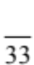

1. Copy and complete these reaction equations.

(a) 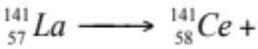 _________

(b) 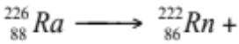 ________

(c) (3)

2. Consider three beams of α, β and γ radiations of equal energy. When passing through matter, they have differing ionising power and penetrating ability.

(a) Arrange them in decreasing order (i.e. highest mentioned first) of:

(i) ionising power.

(ii) penetrating ability.

(2)

(b) Look at the α particle rankings in part (a) above. Explain why you have rated this radiation as you have.

(2)

3. A sample of Ra-233 is delivered to a research laboratory and found to give an α particle count rate of 92 per second. However, over the next month, the count rate diminishes as follows.

TIME (days) | 0 | 5 | 10 | 15 | 20 | 25 | 30
COUNT RATE (s⁻¹) | 92 | 67 | 51 | 38 | 27 | 20 | 15

Plot the data on the graph paper below and determine the half-life.

Half-life: (5)

4. Iodine-131, used in destroying malignant tumours of the thyroid, has a half-life of 8.07 days. If the initial activity (count rate) is 3.20 x 10⁶ Bq at the time of injection, what would be the activity after 3.50 days?

(4)

5. (a) Determine the binding energy per nucleon of a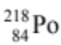 atom. Show all of your working clearly. (Po-218 = 218.10215u)

(4)

(b) Which element has the highest binding energy per nucleon?

(1)

(c) On the diagram below, indicate which elements along the curve undergo fission, and explain why they do.

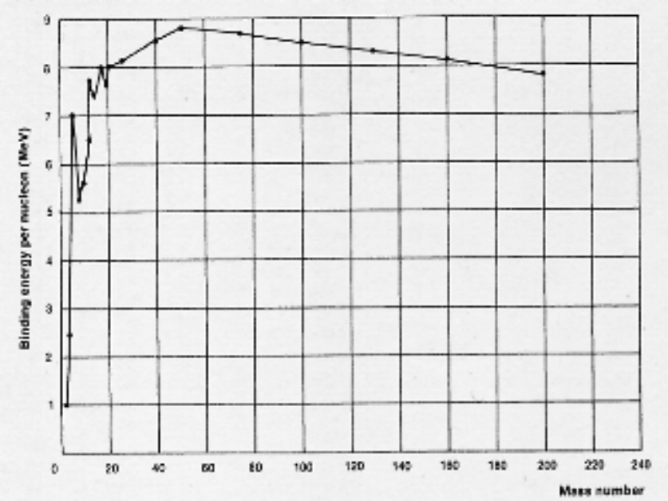

(3)

7. (a) When irradiating a food sample, a scientist uses an absorbed dose of 11.0 kGy of gamma radiation. How much energy would a 245 g sample absorb?

(2)

(b) What dose equivalent would this be if alpha particles were used instead of gamma rays?

(2)

8. Two deuterium nuclei (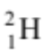) fuse to make helium (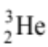) and a neutron.

(a) Write a nuclear equation for this fusion reaction.

(1)

(b) Determine the amount of energy liberated by one such fusion reaction.
(Mass = 3.34354 x 10⁻²⁷ kg, mass = 5.00742 x 10⁻²⁷ kg)

(4)

